1. Introduction
TerraMint is building a next-generation NFT marketplace focused on the tokenization of real-world assets (RWA) — including real estate, fine art, sustainable infrastructure, and high-value collectibles. By leveraging blockchain technology, TerraMint enables fractional ownership, instant liquidity, and global accessibility of traditionally illiquid physical assets. Users can invest in income-generating real-world properties or collectibles via yield-backed NFTs and trade them securely through a fully compliant, on-chain marketplace.
At the core of TerraMint is a compliant smart contract framework, a multi-chain NFT marketplace, and an identity-layered onboarding system that includes KYC/AML, custody, and legal wrappers. Assets are represented by audited, fractionalized tokens or whole-asset NFTs, with metadata and ownership documents stored securely using decentralized storage and verified by oracle networks. TerraMint also integrates with fiat on-ramps, making it easy for both Web3 users and traditional investors to participate.
We are solving a fundamental challenge in global finance: how to unlock the value of real-world assets through secure, borderless, and fractionalized digital markets. Today, over $300 trillion in real estate and collectibles remain largely inaccessible to everyday investors due to high capital requirements, legal complexity, and geographic limits. TerraMint lowers these barriers, enabling fractional investment from as little as $100 — with real ownership, real yield, and full transparency.
The RWA tokenization market is gaining rapid momentum, with leading firms like BlackRock and HSBC exploring on-chain funds and private asset digitization. Analysts project the global tokenized asset market will surpass $10 trillion by 2030. TerraMint is positioned to capture early market share by focusing on high-growth, mobile-driven regions in South Asia, Southeast Asia, and Africa — where demand for alternative assets, crypto access, and digital property is rising fast. India alone has over 35 million crypto users, and the Philippines, Nigeria, and Vietnam rank among the world’s top adopters of blockchain finance and DeFi.
We explain how the platform tokenizes physical assets into yield-generating NFTs, how it ensures compliance and trust through integrated KYC and oracles, and how users can trade and earn in a secure, easy-to-use mobile marketplace. We also share our roadmap and fundraising plan: a pre-seed round of $100K–$250K to finalize MVP development, smart contract audits, and regional launch campaigns. Tokenomics, governance, and DAO features will be detailed in a follow-up document.
TerraMint invites investors, asset partners, and builders to join us in reshaping how the world owns, earns from, and exchanges real-world value.

2. Problem Statement & Vision
Traditional investment in real-world assets (RWAs) — such as real estate, fine art, and infrastructure — remains restricted, opaque, and heavily centralized. Access is often limited to high-net-worth individuals, large institutions, or those with geographic and legal proximity to the asset. The process of buying, selling, or earning yield from these assets involves multiple intermediaries, high entry barriers, and manual legal procedures, making it slow, expensive, and inaccessible to most.
At the same time, existing online marketplaces and tokenization efforts fall short when it comes to trust, compliance, and real ownership. Many “asset-backed” platforms offer limited transparency, rely on central custody, or operate without proper legal frameworks. Users often cannot verify if their digital token truly represents enforceable ownership of the underlying physical asset — or whether that ownership includes rights to yield, resale, or governance.
TerraMint’s vision is to radically transform the way people own, trade, and earn from real-world value by building a fully compliant, on-chain marketplace for fractionalized physical assets. We aim to democratize asset ownership, reduce friction in cross-border investment, and restore transparency and trust through programmable, blockchain-based infrastructure.
In the TerraMint:
- Every real-world asset is tokenized into a legally compliant NFT or ERC-20 token, fully backed by audited legal contracts and real-time verified data.
- Ownership, income rights, and asset governance are codified in smart contracts, removing the need for centralized intermediaries.
- Users anywhere in the world can participate in fractional investment opportunities from as little as $100, with full clarity on what they own and how it earns.
- Asset metadata, legal documentation, and financial performance are stored in decentralized, tamper-proof formats, and validated by on-chain oracles.
- Compliance processes like KYC/AML and jurisdictional checks are embedded at the protocol level, ensuring both user protection and regulatory alignment.
By combining blockchain, legal engineering, and decentralized finance, TerraMint offers a new model for asset ownership — one that is borderless, secure, inclusive, and transparent by design.
Our mission is to unlock true economic participation for millions of people worldwide by making real-world assets as accessible, tradable, and programmable as digital tokens — without compromising compliance, security, or trust.

3. Unique Value Proposition
TerraMint stands apart as a legally compliant, mobile-first, AI-enhanced platform that brings real-world asset (RWA) ownership to a global audience. Unlike most RWA tokenization projects that focus narrowly on real estate or lack regulatory grounding, TerraMint introduces a full-stack, interoperable framework that is secure, scalable, and designed for both institutional and retail adoption.

Legally-Compliant NFTs Backed by Real Assets
Each NFT on TerraMint is directly linked to a legal ownership structure (such as an SPV or trust) that holds the physical asset. These NFTs represent enforceable claims, including ownership, income rights, and governance privileges. Legal documents are hashed and stored on decentralized storage platforms (IPFS, Filecoin), with on-chain proof of existence.
Legal wrappers and jurisdiction-specific compliance modules ensure enforceability of NFT ownership across borders, solving one of the most critical challenges in RWA tokenization.

Borderless Access with a Mobile-First Experience
TerraMint is engineered for mobile-native users, especially in high-growth markets like India, Nigeria, Vietnam, and the Philippines. These users often face barriers in traditional finance due to documentation, onboarding friction, or capital requirements.
TerraMint integrates with local fiat rails (e.g., UPI in India, M-Pesa in Kenya), supports biometric KYC, and offers low-data, multilingual mobile apps for easy access. Onboarding takes minutes, and users can begin investing with as little as $100.

Fractional Ownership and Yield-Generating NFTs
By fractionalizing high-value assets (like property or fine art), TerraMint enables retail users to invest in real assets without full capital exposure. Each fraction represents a pro-rata right to yield (e.g., rental income, royalties, appreciation).
Yield is distributed transparently via smart contracts that follow ERC-4626 or similar standards. Investors can select assets based on risk, region, or yield strategy, and track performance through a personalized dashboard.

AI-Powered Asset Analytics
TerraMint integrates AI to optimize both asset onboarding and investor decision-making. Features include:
- Automated valuation models for real estate and collectibles
- Risk scoring based on location, political stability, asset condition, and legal status
- Predictive yield forecasting trained on historical performance
- NLP-powered contract analysis to highlight red flags in ownership or legal structure
This system makes complex investment data accessible to non-experts and helps mitigate investment risk.

Protocol-Embedded Compliance and KYC/AML
TerraMint incorporates identity and compliance checks directly into its smart contracts using decentralized identity tools (e.g., zkKYC, Verite, Polygon ID). This allows:
- Real-time enforcement of jurisdiction-specific restrictions
- Identity-based token gating for regulated assets
- On-chain audit trails to meet regulator demands
All transfers and secondary trades are validated through compliance oracles, protecting both the platform and users from regulatory violations.

Multi-Chain Support and Interoperability
The marketplace is built on EVM-compatible chains like Polygon and Base, with planned integration for Solana and Sui through bridge protocols like LayerZero and Axelar.
Asset ownership and yield contracts are portable across chains and compatible with major DeFi protocols. This increases liquidity and allows users to manage their TerraMint NFTs from their preferred ecosystem.

DAO-Based Governance
Ownership on TerraMint comes with governance rights. NFT holders vote on:
- Asset onboarding proposals
- Fee structures and marketplace parameters
- Asset lifecycle decisions (e.g., liquidation, refinancing)
- Treasury fund allocation
This introduces community-driven accountability and makes TerraMint adaptable to regional market needs and user preferences.

Diverse Real-World Asset Classes
While many competitors focus only on real estate, TerraMint includes a broader range of tokenizable real-world assets:
- Income-generating real estate (residential, commercial, farmland)
- Tokenized fine art and high-end collectibles
- Sustainable infrastructure (solar farms, EV stations)
- Luxury assets (classic cars, vintage watches)
This diversification provides multiple risk/yield profiles and enhances portfolio resilience for investors.

Programmable Yield and Exit Strategies
Assets on TerraMint can include advanced smart contract features that automate yield distribution, reinvestment, and liquidation triggers:
- Auto-reinvest options for yield compounding
- Scheduled payouts on a monthly or quarterly basis
- Smart exit options if asset underperforms based on pre-defined thresholds
- Rights-splitting: ownership vs. yield vs. governance separable in metadata

These features make TerraMint’s assets more flexible and investor-aligned than traditional securities or NFTs.
Feature | TerraMint | Traditional Market | Other RWA Platforms
Legal Compliance | Protocol-level, built-in | Manual & slow | Partial or unverified
Mobile Accessibility | Mobile-first, local fiat on-ramps | Rare or unavailable | Limited
Yield-Generating NFTs | Yes, standardized and programmable | No | Limited
AI-Powered Asset Intelligence | Yes, integrated risk/yield modeling | None | Absent
DAO Governance | NFT-based voting on key decisions | None | Token-based, limited use
Asset Class Diversity | Real estate, art, infra, luxury | Narrow (mostly real estate) | Primarily real estate
Multi-Chain Support | EVM-based + bridge-ready | Not applicable | Partially interoperable
Embedded KYC/AML | On-chain, automated, jurisdictional | Manual, paper-based | Rare or centralized

4. Technical Architecture
- Asset Tokenization Layer: ERC-721/ERC-1155 NFTs backed by legal SPVs; token metadata on IPFS/Filecoin; notarized by Chainlink/Redstone oracles.
- Compliance & Identity Layer: On-chain KYC/AML (via Polygon ID or similar); jurisdiction-aware smart contracts.
- Trading & Yield Engine: Real-time marketplace for buying/selling fractions; yield distribution via ERC-4626 vaults.
- Cross-Chain Support: Built on EVM (Polygon, Base), with plans for Solana & Sui integration via LayerZero or Axelar bridges.
- Mobile UX Layer: React Native + GraphQL APIs; supports QR-based trades, fiat pay-in/out via local payment rails.

5. Compliance & Legal Framework
- SPV-Based Ownership: Each asset is legally owned via an SPV/LLC, with NFTs representing beneficial interest.
- Dynamic Jurisdictional Logic: Smart contracts auto-adjust based on user nationality or local compliance rules.
- Third-Party Custody or Trusts: Assets are held by registered custodians or legal trustees, ensuring off-chain enforceability.
- Partnerships: Working with firms like LexDAO, Notabene, or local regulatory sandboxes.

6. AI-Powered Asset Analytics
Make your marketplace intelligent:
- AI Valuation Models: Use computer vision and data scraping to price real estate, art, or collectibles fairly.
- Risk Scoring: NLP-based parsing of legal documents and local news feeds to score political, currency, or legal risk.
- Yield Forecasts: Predict rent income or collectible appreciation using LLM + historical data training.
- User Tools: Compare investments with ML-powered dashboards, auto-suggest diversification options.

7. Roadmap

1.MVP & Foundational Layer (Q3 2025 – Q1 2026)
- Launch NFT marketplace MVP on Polygon with fiat on-ramp for India and the Philippines
- Deploy core smart contracts for asset tokenization and fractional yield NFTs
- Integrate identity/KYC layer (Polygon ID, zkKYC)
- List first real estate and luxury collectible assets
- Begin private pre-seed fundraising ($100K–$250K)

2. Regional Expansion & AI Intelligence Layer (Q2 2026 – Q1 2027)
- Expand fiat integrations in Nigeria, Vietnam, Kenya
- Launch AI-powered valuation and risk scoring dashboard
- List fine art, sustainable infrastructure, and collectibles as new asset types
- Begin legal wrapper expansion for cross-border enforceability (SPVs, trusts)
- Conduct smart contract audit and insurance coverage
- Launch NFT-based DAO Lite for limited governance input

3. Open Governance & Multi-Chain Expansion (Q2 2027 – Q1 2028)
- Deploy full DAO governance: community voting on listings, fees, treasury
- Enable asset-backed token listings via community asset onboarding
- Launch on additional chains (Base, Solana, Sui) via LayerZero/Axelar bridges
- Introduce programmable yield contracts with exit triggers
- Partner with DeFi protocols for lending, collateralization, and liquidity

4. Institutional Onboarding & ESG Asset Pools (2028 – 2029)
- Build APIs and compliance frameworks for REITs, funds, and family offices
- Launch ESG asset pools (e.g., solar farms, impact real estate) with verified metrics
- Add legal data feed oracles for jurisdictional updates and compliance monitoring
- Expand AI layer with predictive market analysis, portfolio health scores, and diversification strategies
- Launch professional-grade dashboards for institutions and asset managers

5. Marketplace Automation & AI Governance Support (2029 – 2030)
- Introduce autonomous asset onboarding tools using AI for valuation, legal verification, and yield forecasting
- Implement AI co-pilot for DAO governance: proposal summaries, conflict detection, voting simulations
- Launch auto-matching engine to pair investors with tailored asset baskets
- Begin open ecosystem development with SDKs, APIs, and builder grants

6. Global Legal Interoperability & Asset Insurance (2030 – 2031)
- Partner with global legal firms to create standardized, cross-border asset tokenization frameworks
- Deploy token insurance products for real estate and high-value assets
- Launch fractionalized insurance pools (DeFi-native insurance layer)
- Support tax reporting integrations and national compliance plug-ins

7. TerraMint Global Asset Layer (2031 – 2035)
- Position TerraMint as a global asset layer: powering tokenization for neobanks, wealth platforms, and governments
- Launch national-scale asset tokenization pilots in high-growth economies
- Expand protocol-level governance to include regional DAOs and sub-committees
- Integrate with central bank digital currencies (CBDCs) for public-private investment use cases
- Achieve multi-billion dollar asset value locked (TVL) and real-world adoption at scale

8. Profit Model

1. Transaction Fees
- Fee Rate: 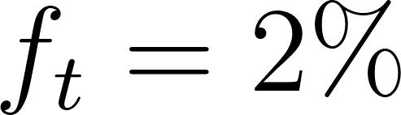 (typical marketplace fee)
- Total Transaction Volume per month: 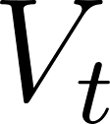 (e.g., $5,000,000)

Monthly Revenue from Transaction Fees:

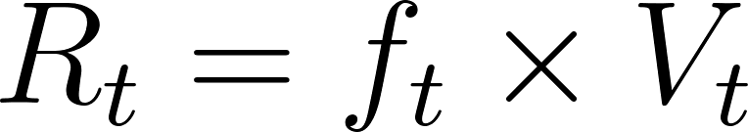
Example:

2. Listing Fees
- Fee per Asset Listed: 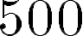
- Number of New Listings per Month: 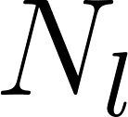 (e.g., 50)

Monthly Revenue from Listings:

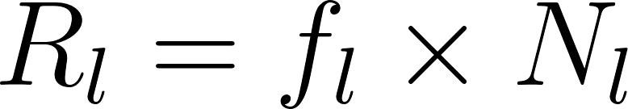

Example:

3. Royalties on Secondary Sales
- Royalty Rate: 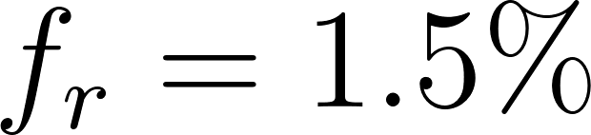
- Secondary Market Volume per Month: 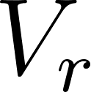 (e.g., $2,000,000)

Monthly Royalty Revenue:

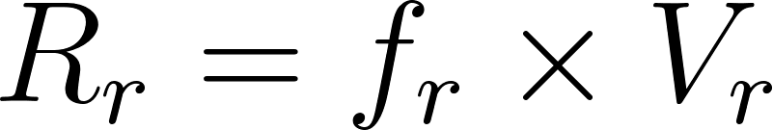

Example:

4. Yield Management Fees
- Average Yield Distributed per Month: 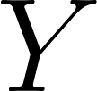 (e.g., $ 200,000)
- Management Fee Rate: 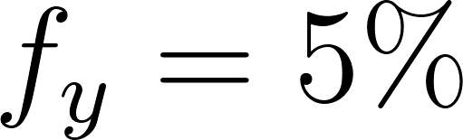

Monthly Revenue from Yield Management:

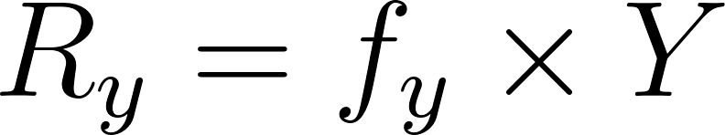

Example:

5. Premium Services Revenue
- Number of Subscribers: 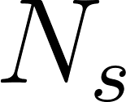 (e.g., 200)
- Subscription Fee: 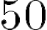

Monthly Premium Revenue:

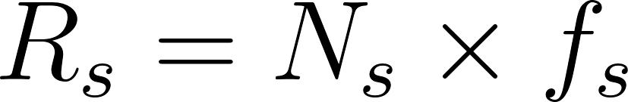

Example:

Total Monthly Revenue:

Example:

Explanation:
- Transaction volume grows by 500k monthly
- Listings increase by 5 each month
- Secondary market volume grows proportionally
- Yield distributed grows by 20k monthly
- Subscribers grow by 20 monthly

9. Investment Allocation Plan

Category | Percentage of Total Investment | Description | Example Amount* (Assuming $1,000,000 Total)
Development | 40% | Smart contract coding, backend & frontend dev | $400,000
Security | 15% | Audits, penetration testing, bug bounties | $150,000
Marketing | 20% | User acquisition, community building, ads | $200,000
Legal & Compliance | 10% | KYC/AML integration, legal consulting, licenses | $100,000
Operations & Admin | 10% | Team salaries, office, admin costs | $100,000
Miscellaneous / Contingency | 5% | Unexpected expenses, buffer | $50,000

Why This Allocation?
- Development (40%): Building a solid, scalable platform is the highest priority, covering both core blockchain and web app features.
- Security (15%): Protecting user assets and platform integrity is crucial—funding audits and security testing reduces risks.
- Marketing (20%): Growth depends on attracting investors, asset owners, and partners through targeted campaigns and community engagement.
- Legal & Compliance (10%): Ensures TerraMint operates within regulatory frameworks, critical for real-world asset tokenization.
- Operations & Admin (10%): Covers essential overhead and team support functions.
- Miscellaneous (5%): Keeps flexibility for unforeseen needs.
How Investment Drives Profitability
- Development enables product launch and feature expansion, directly increasing user and transaction volume.
- Security builds trust, attracting high-value users and partners.
- Marketing fuels growth in transaction volume, listings, and subscribers, increasing revenue streams.
- Legal & Compliance prevents costly fines and ensures smooth operation.
- Operations maintain quality and efficiency.

10. Tokenomics & Governance
(To be detailed in a separate Tokenomics Paper)
- Utility Token: $TERRA — used for fees, staking, rewards, and DAO voting.
- Governance Token: NFT-backed DAO votes on listing assets, fee adjustments, yield strategies.
- Staking Model: Stake $TERRA to earn % of protocol fees and unlock premium features.
- Treasury Usage: DAO votes on grants to legal teams, oracles, community builders.

11. Community & Ecosystem Growth Strategy
TerraMint is building more than a platform — it is cultivating a participatory ecosystem where users, developers, asset partners, validators, and regulators play active roles in expanding access to tokenized real-world assets.
Our growth strategy combines grassroots engagement, technical builder support, incentive design, and regulatory alignment across geographies. We focus on local trust, financial literacy, and economic participation as key drivers of adoption.

Localized Community Activation
We focus on geography-first adoption through regional ambassadors, local partnerships, and language-accessible education. Key pillars include:
- Regional Ambassadors
Appoint trained local representatives in India, Nigeria, Vietnam, the Philippines, and Kenya
Support with grant stipends, merch, onboarding tools, and access to partner events
Host meetups, AMAs, and workshops to promote financial literacy and tokenized investing
- Hyperlocal Education Campaigns
Launch video explainers, WhatsApp community groups, and vernacular-language investor guides
Partner with NGOs or fintech incubators for co-branded RWA education
Distribute a “Real Asset Starter Kit” that explains investing with $100 or less
- KYC Simplification Drives
Offer fiat incentives or token rewards for completing on-chain identity
Provide community guides on passing KYC in specific regions

Builder & Developer Incentives
To grow TerraMint as a modular ecosystem, we provide support and capital for builders:
- Ecosystem Grants Program
Launch a rolling grant program for smart contract developers, mobile integrators, and legal tech teams
Prioritize dApps focused on asset onboarding, compliance automation, or alternative yield mechanisms
Publish open RFPs (Request for Proposals) for DAO tooling, NFT collateralization, and AI integrations
- Hackathons & Bounties
Organize global and regional hackathons (virtual and in-person)
Offer bounties for:
AI tools for NFT valuation
Compliance rule modules
Marketplace extensions
SDK development (JavaScript, Solidity)

- Developer Portal
Release public APIs and SDKs for asset listing, user onboarding, and compliance checks
Provide documentation, testnets, and sandbox environments
Offer technical support via Discord and GitHub Issues

Referral & Reward Programs
User growth and retention will be incentivized through transparent and gamified programs:
- Referral Rewards
Users earn stablecoins or yield bonuses for referring KYC-verified users
Tiered rewards based on volume and community engagement
Regional leaderboard campaigns to recognize top ambassadors
- Liquidity & Listing Incentives
Asset originators receive yield multipliers or protocol grants for high-quality listings
Early investors in newly listed assets get fee discounts or governance boosts
Validators and auditors are rewarded with NFT-based reputation scores
- Reputation and Loyalty System
Build a reputation layer based on asset review accuracy, on-time yield delivery, and KYC behavior
High-reputation users unlock early access to premium assets, DAO proposals, or beta features

Ecosystem Partnerships
TerraMint will grow its ecosystem by partnering with:
- Real Estate Brokers & Art Dealers
Revenue share agreements for verified asset sourcing
Co-marketing with local agencies to tokenize physical inventory
Training and onboarding tools for listing assets legally and securely
- Legal & Custodial Partners
Collaborate with regional law firms to provide asset wrappers for different jurisdictions
Work with licensed custodians for trust-based ownership of physical assets
Develop pre-approved wrapper templates to speed onboarding
- Fintech and DeFi Protocols
Integrate with payment providers, wallets, and credit platforms
Partner with DeFi platforms for collateralization of yield NFTs or LP tokens
Enable NFT staking, lending, and borrowing for composable finance

Community DAO & Progressive Decentralization
TerraMint will shift toward a community-owned protocol over 3 phases:
- DAO Lite (2026)
Limited governance over asset approvals and treasury proposals
Voting rights based on NFT holdings or staked utility tokens
- DAO Expansion (2027)
Launch sub-DAOs based on regions, asset types, or compliance zones
Empower community committees to run audits, resolve disputes, or onboard partners
- Full DAO Governance (2028+)
Treasury and platform upgrades fully controlled by token holders and NFT stakeholders
Quarterly governance cycles, proposal funding rounds, and off-chain signaling tools

Trust-Building and Transparency
Trust is central to onboarding real-world value onto the blockchain. TerraMint ensures transparency through:
- Quarterly Transparency Reports
Publish full breakdowns of TVL, active users, asset status, and yield performance
Include audit results, governance decisions, and treasury spending summaries
- Open Legal Repository
Maintain an open-source archive of legal templates, compliance checklists, and jurisdictional guides
Allow lawyers and regulators to contribute updates via GitHub and DAO grant proposals
- Community Treasury
Allocate a portion of protocol fees to fund community-chosen initiatives
Use on-chain voting to approve initiatives for legal innovation, education, or security audits

